Menstrual Hygiene Awareness in Adolescent Girls: Exploring the Influence of Maternal Education on Knowledge and Practices in a Sub-Urban Area of Pakistan
Supervisor: Dr Naureen Omar
Investigators: Dr Ayesha Javed, Dr Fatima Sohail

Abstract
Menstrual hygiene management remains an important adolescent health concern in low-resource settings. Stigma, limited menstrual health knowledge, and poor access to safe hygiene materials can affect health, dignity, and school participation [1-3]. Maternal education is often considered a determinant of adolescent health behavior, but evidence from sub-urban Pakistan is limited. This study assessed menstrual hygiene knowledge and practices among adolescent girls and examined differences across maternal education categories. The analysis used a finalized school-based survey dataset from a sub-urban area of Lahore, Pakistan. The SPSS source file contained 160 raw records. Forty fully blank trailing records were removed, leaving 120 participants for analysis. Knowledge scores could range from 0 to 9, and practice scores could range from 0 to 7. Scores were calculated from archived questionnaire rules, with one adjudicated correction. Missing questionnaire responses were scored as zero. The analysis included descriptive statistics, data quality checks, group comparisons, and correlations. Kruskal-Wallis tests were used for the primary group comparisons because the scores were bounded and discrete and the maternal education groups were imbalanced. Mean age was 14.47 years (range 12-18 years). Mean knowledge score was 6.65/9 (SD 1.22), and mean practice score was 5.68/7 (SD 0.58). The practice-score comparison was nominally significant only in the unadjusted analysis (Kruskal-Wallis H = 10.1562, unadjusted p = 0.0379, epsilon-squared = 0.0853; Holm-adjusted p = 0.0758). The omnibus knowledge comparison was not statistically significant (H = 8.0427, p = 0.0900, epsilon-squared = 0.0676). Age was positively correlated with knowledge (r = 0.314, p = 0.0005), and knowledge was positively correlated with practice (r = 0.317, p = 0.0004). The post-processing issue-free cell rate was 88.70% overall and 99.70% after conditional and skip-logic variables were excluded. The complete-case practice analysis was also not statistically significant (H = 8.6488, p = 0.0705). These findings do not establish an independent effect of maternal education. The practice result is exploratory because it was nominally significant only before multiplicity correction, was sensitive to missing-response handling, and may be confounded by age. Ethics approval and study-specific consent documentation could not be verified from the archived materials and must be resolved before submission.
Keywords: menstrual hygiene; adolescent girls; maternal education; Pakistan; school health; cross-sectional study

1. Introduction
Adolescence is a period in which many health-related attitudes and behaviors develop and may continue into adulthood. Menstrual health is an important part of adolescent well-being. Girls must manage menarche, menstrual cycles, personal hygiene, and social stigma, sometimes without adequate information or material support. Guidance from the World Health Organization and UNESCO treats menstrual health as an issue of health, education, rights, and gender equity. Effective menstrual health support requires suitable hygiene materials, accurate knowledge, supportive social norms, and safe sanitation [1-3].
In low- and middle-income settings, menstrual hygiene management may be limited by social silence, cultural taboos, lack of privacy, and inadequate access to absorbents and disposal facilities. Some girls reach menarche without prior preparation and depend on informal or incomplete information. These conditions may reduce hygienic practice, cause discomfort and embarrassment, and disrupt school attendance and social participation. Studies from Ghana, Ethiopia, Nepal, India, and related settings indicate that menstrual knowledge and practices are associated with parental education, access to information, and wider socioeconomic conditions [4-10].
Family circumstances and maternal education may be especially relevant in sub-urban communities in Pakistan, where education, household resources, and social norms vary. Maternal education may affect daughters' menstrual hygiene through communication, supervision, examples of hygienic routines, and access to menstrual products. However, higher maternal education may not produce large differences in formal knowledge when girls also learn from peers, media, or schools. This study assessed menstrual hygiene knowledge and practices among adolescent girls in a sub-urban area of Lahore, Pakistan, and examined differences across maternal education categories.

2. Rationale and Objectives
This analysis considered whether maternal education was more closely related to girls' knowledge about menstruation or to their menstrual hygiene practices. The distinction matters because improved awareness may not change behavior when household conditions, product access, or sanitation remain limiting. The primary objectives were to assess menstrual hygiene knowledge and practice scores and determine whether these scores differed by maternal education level. Secondary objectives were to describe the participants' demographic characteristics and household economic indicators and to examine correlations among age, income, family size, and menstrual hygiene scores.

3. Methods

3.1 Study design, setting, and source protocol
This manuscript presents a structured secondary analysis of the finalized survey dataset in the project workspace. The source protocol in doc.md described a school-based questionnaire study planned for the nine months from March to December 2024 at Reach School on Sau Asal Road, Lahore. The planned procedures included school-based recruitment, a structured questionnaire administered by the primary investigators, and an interview lasting about 15 to 20 minutes for each participant.

3.2 Participant selection and analytic sample
According to the source protocol, adolescent girls were eligible if parental consent was provided. Students without parental consent and those who did not wish to participate were to be excluded. The protocol specified simple random sampling by lottery from a prepared list of eligible female students. The finalized analytic workflow loaded 160 raw records from the SPSS source file. Forty fully blank trailing records were removed, leaving 120 valid participant records.

3.3 Study variables
The main outcomes were menstrual hygiene knowledge score and menstrual hygiene practice score. Knowledge was measured as a bounded discrete score from 0 to 9, and practice was measured as a bounded discrete score from 0 to 7. Maternal education was the primary explanatory variable. The SPSS metadata coded it as 1 = Illiterate, 2 = Primary, 3 = Middle, 4 = Secondary, and 5 = Intermediate and above. Other descriptive and exploratory variables were age, paternal education, maternal occupation, paternal occupation, monthly household income, family size, and per-capita income.

3.4 Scoring rules and derived variables
The knowledge score was calculated from the Section III questionnaire items using the archived scoring protocol, with one adjudicated correction. The archived key assigned the menstruation-process point to code 2, although the SPSS metadata labeled code 1 as physiological/natural and code 2 as pathological/disease. Because menstruation is physiological rather than pathological, code 1 received the point in the corrected primary analysis. The original coding was retained for sensitivity analysis and audit purposes.
The practice score was calculated from the Section IV questionnaire items according to the archived scoring scheme. Missing or out-of-label questionnaire responses were assigned a score of zero under the implemented rules. Four archived score items gave one point for every listed response option: the absorbent and change-frequency items in both the knowledge and practice sections. These items contributed to the total scores but did not distinguish among participants. Per-capita income was calculated by dividing monthly household income by the total number of family members. It was set to null rather than imputed when income or family size was missing or when family size was zero.

3.5 Data quality procedures
The analysis pipeline produced a separate data quality report covering missing values, categorical values outside the labeled domains, and the proportions of affected rows and columns. Categorical responses were compared with the value domains in the SPSS metadata. Several questionnaire items were conditional follow-up questions. The workflow therefore separated overall data quality from core data quality so that expected skip-pattern missingness would not be treated as poor data capture. A consistency check also compared reported total family size with the sum of male and female family members.

3.6 Statistical analysis
All statistical tests used a two-sided significance threshold of 0.05. Categorical variables were summarized with counts and percentages. Continuous variables were summarized with the mean, median, standard deviation, minimum, maximum, and quartiles. Knowledge and practice scores were the two principal outcomes.
Before group comparisons were selected, Shapiro-Wilk tests were used to assess within-group normality when group size allowed. Levene's test was used to assess homogeneity of variance when feasible, and small group sizes were identified as a further limitation of parametric analysis. Because the scores were bounded and discrete and the maternal education groups were markedly imbalanced, the primary comparisons used Kruskal-Wallis tests. Epsilon-squared was reported as the effect size. The primary p-values are presented without adjustment, and Holm correction across the two outcomes was used to examine familywise robustness.
Pearson complete-case correlations were used to assess linear associations among age, income, family size, per-capita income, knowledge score, practice score, and total score. These secondary correlations were exploratory and were not corrected for multiple testing. Because income was strongly right-skewed and susceptible to outliers, Spearman rank correlations were calculated as sensitivity analyses. Other sensitivity analyses repeated the Kruskal-Wallis tests after excluding the highest maternal education category, treated maternal education as an ordinal rank, tested whether age differed among maternal education groups, and applied the archived scoring key.

3.7 Ethical considerations
The source protocol planned parental consent, confidentiality, anonymity, school permission, and institutional review. The archived analysis materials do not confirm that these procedures were completed. They contain no reportable ethics approval identifier, and the appended consent text relates to bullying rather than menstrual hygiene. The correct study-specific consent form and ethics record must be confirmed before submission. No claim of ethics approval or consent is made because these could not be verified from the archived record.

4. Results

4.1 Participant flow
The finalized SPSS file contained 160 raw records. Forty fully blank trailing records were removed, leaving 120 participant records in the analytic sample. Table 1 shows the participant flow.
Stage | n
Raw records loaded | 160
Removed (fully blank trailing records) | 40
Final records analyzed | 120

4.2 Demographic and household characteristics
Mean participant age was 14.47 years (SD 1.40), with a range of 12 to 18 years. Monthly household income varied widely. The mean was 48,833.33, and the maximum was 600,000, indicating substantial right-skewness. Mean family size was 6.66 members, and mean per-capita income was 8,648.83. Maternal education was concentrated in the lower categories: 71.7% of participants were in the illiterate category, and 14.2% were in the primary category. Only one participant was in the Intermediate and above category. Table 2 gives the full demographic summary.
Variable | Category/Statistic | Value
Age (years) | Mean +/- SD | 14.47 +/- 1.40
Age (years) | Median (IQR) | 14.0 (13.0-15.0)
Age (years) | Range | 12-18
Monthly income | Mean +/- SD | 48,833.33 +/- 57,440.99
Monthly income | Median (IQR) | 45,000 (30,000-50,000)
Family size | Mean +/- SD | 6.66 +/- 2.38
Family size | Median (IQR) | 6 (5-8)
Per-capita income | Mean +/- SD | 8,648.83 +/- 10,763.62
Per-capita income | Median (IQR) | 6,428.57 (4,285.71-10,000)
Maternal education | Illiterate | 86 (71.7%)
Maternal education | Primary | 17 (14.2%)
Maternal education | Middle | 8 (6.7%)
Maternal education | Secondary | 8 (6.7%)
Maternal education | Intermediate and above | 1 (0.8%)
Maternal occupation | Non-working | 103 (85.8%)
Maternal occupation | Working | 14 (11.7%)
Maternal occupation | Other/unlabeled code | 3 (2.5%)
Paternal education | Primary | 35 (29.2%)
Paternal education | Middle | 28 (23.3%)
Paternal education | Secondary | 24 (20.0%)
Paternal education | Illiterate | 24 (20.0%)
Paternal education | Intermediate and above | 9 (7.5%)

4.3 Knowledge and practice score distributions
Knowledge scores ranged from 3 to 9. The mean was 6.65, and the median was 7.00. Practice scores ranged from 4 to 7, with a mean of 5.68 and a median of 6.00. Practice scores were more closely clustered than knowledge scores. A knowledge score of 7 was the most common knowledge result (37.5%), and a practice score of 6 was the most common practice result (71.7%). Table 3 summarizes the distributions.
Score domain | Summary
Knowledge score (0-9) | Mean 6.65, Median 7.00, SD 1.22, Min 3, Max 9
Practice score (0-7) | Mean 5.68, Median 6.00, SD 0.58, Min 4, Max 7

Figure 1 shows the overall score distributions.

4.4 Scores by maternal education
Group summaries showed modest increases in mean scores across higher maternal education categories. Interpretation is limited by the pronounced imbalance among groups, particularly the single participant in the highest category. Mean knowledge scores ranged from 6.53 in the illiterate and primary categories to 8.00 in the Intermediate and above category. Mean practice scores ranged from 5.59 in the illiterate category to 6.12 in the secondary category. Table 4 presents the group summaries.
Maternal education level | n | Knowledge mean +/- SD | Knowledge median (IQR) | Practice mean +/- SD | Practice median (IQR)
Illiterate | 86 | 6.53 +/- 1.27 | 7.0 (6.0-7.0) | 5.59 +/- 0.62 | 6.0 (5.0-6.0)
Primary | 17 | 6.53 +/- 1.23 | 7.0 (7.0-7.0) | 5.76 +/- 0.44 | 6.0 (6.0-6.0)
Middle | 8 | 7.38 +/- 0.52 | 7.0 (7.0-8.0) | 6.00 +/- 0.00 | 6.0 (6.0-6.0)
Secondary | 8 | 7.25 +/- 0.71 | 7.0 (7.0-8.0) | 6.12 +/- 0.35 | 6.0 (6.0-6.0)
Intermediate and above | 1 | 8.00 | 8.0 (8.0-8.0) | 6.00 | 6.0 (6.0-6.0)

Figures 2 and 3 display these group patterns as bar plots with error bars and as box plots.

4.5 Inferential analysis for maternal education
The assumption checks did not support parametric group comparisons. Kruskal-Wallis tests were therefore used for both outcomes. The omnibus knowledge-score comparison was not statistically significant (H = 8.0427, unadjusted p = 0.0900, epsilon-squared = 0.0676). The practice-score comparison was nominally significant only before correction for multiple testing (H = 10.1562, unadjusted p = 0.0379, epsilon-squared = 0.0853). Its Holm-adjusted p-value was 0.0758. Thus, the practice result is exploratory and is not robust to familywise error correction. The nominal result for practice and the non-significant result for knowledge do not establish that the two associations differ. Table 5 gives the inferential results.
Outcome | Test | Statistic | p-value | Effect size (epsilon-squared) | Interpretation
Knowledge score | Kruskal-Wallis | H = 8.0427 | 0.0900 | 0.0676 | Omnibus comparison not statistically significant
Practice score | Kruskal-Wallis | H = 10.1562 | 0.0379 | 0.0853 | Nominal p < 0.05; Holm-adjusted p = 0.0758

4.6 Correlation analysis
In the Pearson complete-case analysis, age was positively correlated with knowledge (r = 0.314, p = 0.0005) and practice (r = 0.267, p = 0.0032). Knowledge and practice were also positively correlated (r = 0.317, p = 0.0004). Family size was negatively correlated with knowledge (r = -0.201, p = 0.0279). Neither household income nor per-capita income was significantly correlated with either score in the Pearson analysis. These findings are exploratory because multiple correlations were examined without adjustment. Correlations involving total score were not interpreted because total score is derived mathematically from the knowledge and practice scores. Table 6 presents the score-related correlations.
Variable pair | r | p-value | Interpretation
Age vs Knowledge score | 0.314 | 0.0005 | Moderate positive association
Knowledge score vs Practice score | 0.317 | 0.0004 | Weak-to-moderate positive association
Age vs Practice score | 0.267 | 0.0032 | Weak positive association
Family size vs Knowledge score | -0.201 | 0.0279 | Weak negative association
Family size vs Practice score | -0.165 | 0.0725 | Not significant
Income vs Knowledge score | -0.042 | 0.6501 | Not significant
Income vs Practice score | -0.122 | 0.1834 | Not significant
Per-capita income vs Knowledge score | 0.040 | 0.6637 | Not significant
Per-capita income vs Practice score | -0.077 | 0.4040 | Not significant

Figure 4 shows a scatter matrix of the continuous-variable relationships.

4.7 Data quality and sensitivity analyses
After processing, 550 cells were missing and six categorical responses were outside the labeled domains among 4,920 cells in the transformed 41-column dataset. The overall issue-free cell rate was therefore 88.70%. This denominator includes optional free-text fields and five derived fields. The out-of-label values were three maternal occupation codes of 3, two menstruation-process codes of 5, and one handwashing code of 3. Core issue-free cell rate was 99.70% after conditional and skip-logic variables were excluded. The family-size check found no differences between reported total family size and the sum of male and female family members.
Excluding the one participant in the highest maternal education category did not materially change the findings. The knowledge comparison remained non-significant (H = 6.3719, p = 0.0949, epsilon-squared = 0.0540), and the unadjusted practice comparison remained below 0.05 (H = 9.7515, p = 0.0208, epsilon-squared = 0.0826). However, the analysis restricted to 115 participants with complete responses on all seven practice items was not statistically significant (H = 8.6488, p = 0.0705). The nominally significant unadjusted primary practice result was therefore sensitive to the archived missing-as-zero rule.
When maternal education was treated as ordinal, it had positive rank correlations with knowledge (rho = 0.2023, p = 0.0267) and practice (rho = 0.2684, p = 0.0030). These exploratory trend tests were not corrected for multiple testing. Age differed among maternal education groups (H = 10.6913, p = 0.0303), so age is a plausible confounder. Spearman analyses retained positive associations between age and knowledge (rho = 0.3710, p < 0.001) and between knowledge and practice (rho = 0.3650, p < 0.001). In contrast to the Pearson result, the Spearman analysis found a weak positive association between income and knowledge (rho = 0.2160, p = 0.0178), while income and practice remained non-significant. Use of the archived pathological-response key rather than the adjudicated physiological-response key gave a mean knowledge score of 5.82 and a non-significant omnibus comparison (H = 5.8669, p = 0.2093, epsilon-squared = 0.0493). Table 7 summarizes the sensitivity analyses.
Sensitivity analysis | Knowledge result | Practice result | Interpretation
Excluding maternal education level 5 (n = 1) | H = 6.3719, p = 0.0949, epsilon-squared = 0.0540 | H = 9.7515, p = 0.0208, epsilon-squared = 0.0826 | Unadjusted practice p remains below 0.05; knowledge remains non-significant
Complete practice responses only | Unchanged | H = 8.6488, p = 0.0705, epsilon-squared = 0.0759; n = 115 | Practice result is sensitive to missing-response handling
Maternal education treated as ordinal | rho = 0.2023, p = 0.0267 | rho = 0.2684, p = 0.0030 | Exploratory monotonic trends; unadjusted for multiplicity
Age across maternal-education groups | H = 10.6913, p = 0.0303 | - | Age is a plausible confounder
Archived pathological-response scoring key | Mean 5.82; H = 5.8669, p = 0.2093, epsilon-squared = 0.0493 | Unchanged | Main significance classification is unchanged
Spearman rank correlation (age-knowledge) | rho = 0.3710, p < 0.001 | - | Positive association remains
Spearman rank correlation (knowledge-practice) | rho = 0.3650, p < 0.001 | - | Positive association remains
Spearman rank correlation (income-knowledge / income-practice) | rho = 0.2160, p = 0.0178 | rho = 0.0544, p = 0.5550 | Weak income-knowledge association appears only in the rank-based analysis

5. Figures

Figure 1. Distribution of knowledge and practice scores
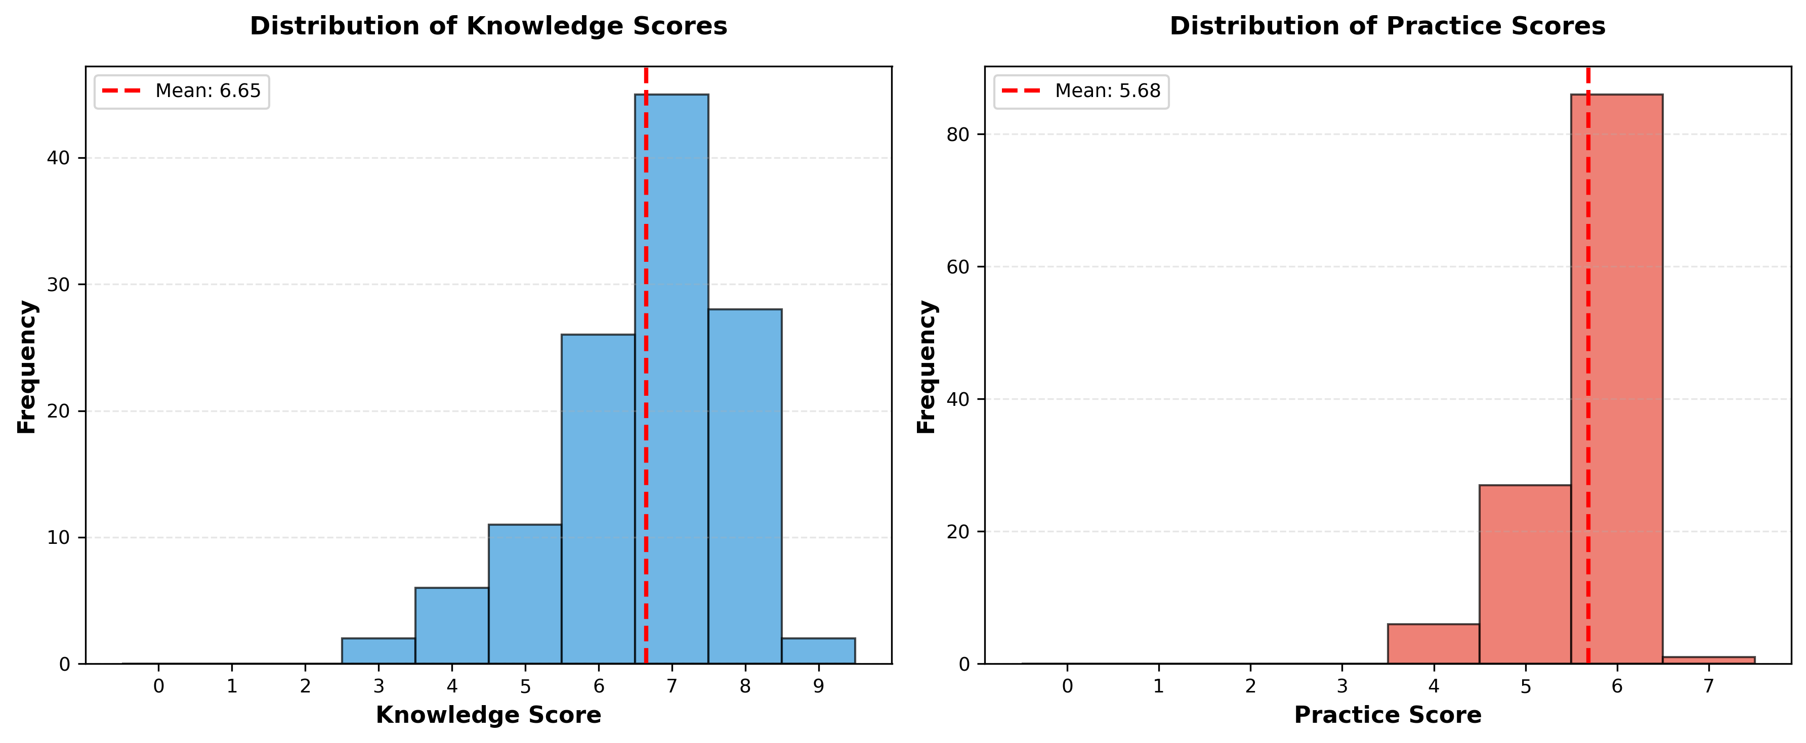
Figure 1. Knowledge and practice score distributions.

Figure 2. Mean knowledge and practice scores by maternal education level
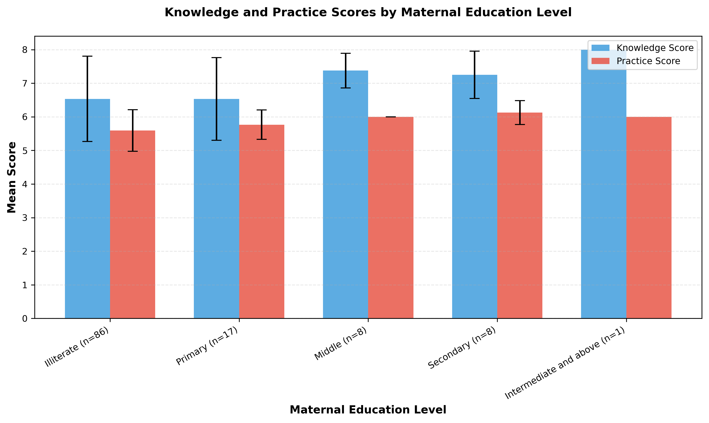
Figure 2. Mean knowledge and practice scores by maternal education level.

Figure 3. Boxplots of knowledge and practice scores by maternal education level
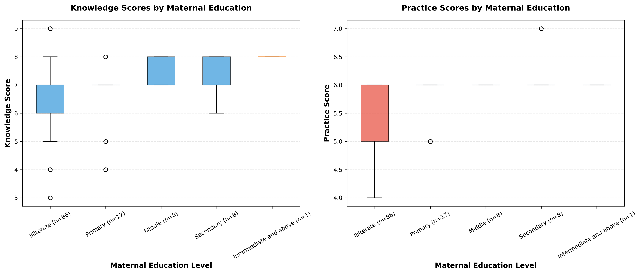
Figure 3. Boxplot comparison by maternal education level.

Figure 4. Scatter matrix of continuous variables
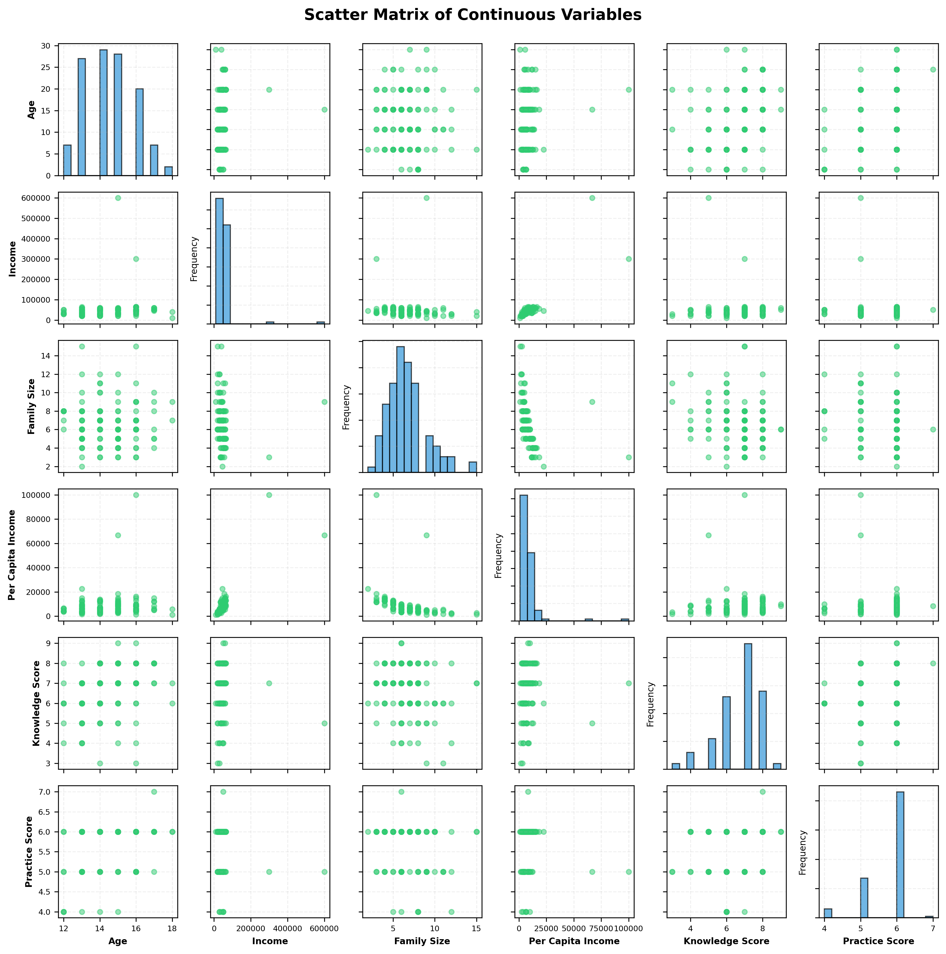
Figure 4. Scatter matrix for age, income, family size, per-capita income, knowledge, practice, and total score.

6. Discussion
The primary analysis found a nominally significant unadjusted difference in practice scores among maternal education groups. The omnibus knowledge comparison was not statistically significant. The practice result did not remain significant after Holm correction for the two principal outcomes (Holm p = 0.0758), and the complete-case practice analysis was also not significant (p = 0.0705). No formal test compared the strength of the knowledge and practice associations. The practice finding must therefore be regarded as exploratory. Household routines, access to products, supervision, and age could contribute to the observed pattern, but this unadjusted analysis cannot separate their effects.
The positive association between age and knowledge is consistent with a developmental explanation. Older girls may have more experience of menstruation and more opportunities to receive information from family members or peers. They may also have had more time to develop their understanding of menstrual management. Knowledge and practice were positively correlated, but the association was not strong enough to assume that knowledge consistently leads to practice. Structural barriers, stigma, and limited access may affect whether knowledge can be applied.

6.1 Comparative review methods
For comparison with published evidence, PubMed and OpenAlex were searched for primary studies addressing menstrual hygiene knowledge, practice, maternal or parental education, and enabling resources among adolescents. Studies from Pakistan were prioritized, followed by studies from other South Asian settings and one Ethiopian study that reported directly comparable adjusted models for maternal education. DOI identities were checked using Crossref and the DOI Handle service. Twelve primary studies were included: five from Pakistan, six from other South Asian settings, and one from Ethiopia. Full text was reviewed for 11 studies. For one Nepal study, only the publisher abstract was available because the article PDF could not be obtained. The studies differed in instruments, thresholds, populations, and definitions of good knowledge or practice. For this reason, no pooled estimate was calculated, and nominal percentages were not ranked directly.

6.2 Comparison with published studies
Study | Main comparable finding | Relationship to the present study
Wasan et al., rural Sindh [11] | Only 25% of 25,305 participants used materials classified as appropriate; no participant education versus higher secondary/university predicted inappropriate material use (OR 3.90, 95% CI 3.36-4.52). | Supports an education-practice pathway and a strong role for material access, but measured the participant's education rather than maternal education.
Aziz et al., Khairpur, Sindh [12] | Satisfactory knowledge was 69.8% in the urban school and 38.4% in the rural school; good practice was 71.1% and 11.9%, respectively. Mothers were the main information source in both groups. | Demonstrates major contextual variation within Pakistan but did not test maternal education against outcomes.
Shah et al., Ghizer, Pakistan [13] | Among 300 girls, 51.7% lacked awareness at menarche, 47.7% used reusable cloth/towels, and 30.7% used disposable pads; 65.3% of mothers had no education. | Supports a maternal information pathway, but maternal education was discussed rather than statistically tested.
Michael et al., Quetta, Pakistan [14] | Mothers were the main information source for 67%; 77.7% had received no school menstrual-education session; 68.7% used commercial pads. | Reinforces reliance on maternal information while showing that knowledge and product use can diverge.
Afzaal et al., rural Lahore [15] | Knowledge and practice were positively correlated (r = 0.649, p < 0.001). | The closest geographic comparator agrees with the present positive knowledge-practice correlation, but did not report a maternal-education association.
Dasgupta and Sarkar, rural India [16] | Although 48.75% knew sanitary pads were appropriate, only 11.25% used them. | Shows that knowledge does not ensure practice.
Kansal et al., rural India [17] | Girls with literate mothers used pads more often than girls with illiterate mothers (62% vs 13%); the association was significant. | Directly agrees with the direction of the present maternal-education/practice finding, although hygiene definitions differed.
Yadav et al., Nepal [18] | Most respondents had fair or good knowledge, but only 40% of girls met the study's good-practice definition. | Supports separate assessment of knowledge and practice.
Bhusal, Nepal [7] | Literate mothers were associated with lower adjusted odds of good practice (AOR 0.52, 95% CI 0.30-0.88), while literate fathers had higher odds. | Contradicts the expected direction and shows that maternal education is not a universal stand-alone proxy for a supportive menstrual environment.
Haque et al., Bangladesh [19] | After an uncontrolled six-month school intervention, high knowledge increased from 51.0% to 82.4% and good practice from 28.8% to 88.9%. | Supports intervention feasibility, but the design cannot establish that education alone caused or sustained the changes.
Alam et al., Bangladesh [20] | Accessible girls' toilets were associated with less menstrual-related absence (adjusted prevalence difference -5.4 percentage points, 95% CI -10 to -1.6); restrictions were associated with more absence. | Shows that facilities and social rules can shape behavior independently of knowledge or maternal schooling.
Upashe et al., Ethiopia [21] | Maternal secondary-or-higher education predicted good knowledge (AOR 1.51, 95% CI 1.02-2.22) and good practice (AOR 2.03, 95% CI 1.38-2.97). | Agrees with the present practice association but differs by also finding a knowledge association.

The direction of the nominally significant unadjusted practice result agrees with Kansal et al. and Upashe et al., while Bhusal reported an inverse adjusted association [7,17,21]. Maternal education therefore does not have a consistent relationship with practice across settings. The absence of a statistically significant knowledge association in the present analysis also differs from the findings of Upashe et al. [21]. Direct numerical comparison is not appropriate because the studies differed in outcome definitions, age groups, maternal education categories, adjustment for confounding, and setting. The present study used continuous bounded scores and unadjusted group comparisons, whereas several comparison studies used study-specific binary thresholds and multivariable logistic regression.
Studies from Pakistan often identify mothers as an important source of menstrual information [12-14], but most do not estimate whether maternal education independently predicts knowledge or practice. This study provides a direct local comparison without assuming that frequent communication with mothers necessarily provides accurate information. The positive correlation between knowledge and practice agrees with the rural Lahore study [15]. Findings from Nepal and India also show that adequate knowledge can coexist with weaker practice [16,18].
The published evidence further supports treating knowledge and practice as separate outcomes. The cost and availability of products, household resources, privacy, sanitation, school facilities, and social restrictions may either support or prevent hygienic behavior [11,20]. Some routines may also be learned through social practice despite limited formal knowledge. Any association between maternal education and menstrual hygiene may therefore involve several mechanisms, including communication, purchasing power, supervision, and household norms, rather than education alone.
This study has several strengths. The reproducible analysis pipeline preserved timestamped outputs and included explicit data quality reporting, documented assumption checks, and effect sizes as well as p-values. The workflow also checked the internal consistency of family-size reports. Sensitivity analyses showed that the broad conclusions were unchanged after removal of the single participant in the highest education category and when rank-based correlations were used.
Several limitations require caution. First, the cross-sectional design supports associations but not causal conclusions. Second, the analyses were unadjusted and bivariate. Age differed among maternal education groups and may confound the observed associations. School conditions, product access, and other family factors were not controlled. Third, the practice comparison was only nominally significant in the unadjusted primary analysis and did not remain significant after Holm correction. Fourth, maternal education groups were severely imbalanced, especially the highest category. This limits precision, makes detailed comparisons unstable, and means that the omnibus result does not identify which groups differ. Fifth, assigning zero to missing or invalid questionnaire responses may have lowered scores when non-response did not indicate poor knowledge or practice. The non-significant complete-case result confirms that the nominal practice finding was sensitive to this rule. Sixth, four score items did not discriminate because every listed response option received one point. This limits construct validity and increases the apparent proportion of the maximum score. Seventh, one knowledge item required post hoc adjudication because the archived scoring key conflicted with the biological meaning of its labeled responses. Eighth, six responses fell outside the SPSS value-label domains. Ninth, the secondary correlations and ordinal trends were exploratory and were not corrected for multiple testing. Finally, participants came from one school, so the findings may not generalize to other adolescents in Lahore or elsewhere in Pakistan.
The results suggest that programs in similar settings should address practical behavior as well as factual menstrual health knowledge. Possible components include caregiver involvement and measures to improve access to products, privacy, and safe disposal. Larger and more balanced samples, adjusted multivariable models, and prospective or mixed-methods designs are needed to clarify how maternal education relates to menstrual hygiene behavior in everyday settings.

7. Conclusion
In this sample from sub-urban Lahore, practice scores differed across maternal education groups only at the unadjusted 0.05 level. The practice comparison was nominally significant unadjusted, but it was not significant after Holm correction (p = 0.0758) or in the complete-case sensitivity analysis (p = 0.0705). The omnibus knowledge comparison was not statistically significant. Age may confound the group differences. In exploratory analyses, older age was associated with higher knowledge and practice scores, and knowledge was positively associated with practice. These cross-sectional results are hypothesis-generating and do not provide causal evidence. Firm conclusions about the independent role of maternal education require larger studies with validated scoring, balanced education groups, documented ethics procedures, and adjusted analyses.

8. Declarations

Ethics statement
The source protocol planned parental consent, confidentiality, anonymity, school permission, and institutional review. The archived materials contain neither a reportable ethics approval identifier nor a valid consent form specific to menstrual hygiene; the appended consent text concerns bullying. Ethics approval and consent cannot be confirmed from the available record and must be resolved before submission.

Funding
The analysis bundle provided no information about external funding.

Competing interests
No competing interests were declared in the available source materials.

Data and materials availability
This manuscript was prepared from the corrected analysis outputs stored in output/analysis_20260712_224950/. The archived materials did not include public repository information. This information should be added if the target journal requires it.

Author contributions
The title page reports the supervisor and investigator roles. Statistical processing and manuscript assembly used the documented local analysis workflow.

9. References
- World Health Organization. Strengthening the health sector response to adolescent health and development. Geneva: WHO; 2010. Available from: https://apps.who.int/iris/bitstream/handle/10665/340531/WHO-FCH-CAH-10-01-eng.pdf?sequence=1&isAllowed=y (No DOI; accessed 2026-03-19).
- World Health Organization. WHO statement on menstrual health and rights. 22 June 2022. Available from: https://www.who.int/news/item/22-06-2022-who-statement-on-menstrual-health-and-rights (No DOI; accessed 2026-03-19).
- UNESCO. Puberty and menstrual hygiene management. Available from: https://www.unesco.org/en/health-education/puberty (No DOI; accessed 2026-03-19).
- Kumbeni MT, Otupiri E, Ziba FA. Menstrual hygiene among adolescent girls in junior high schools in rural Northern Ghana. Pan Afr Med J. 2020;37:190. https://doi.org/10.11604/pamj.2020.37.190.19015
- Sahiledengle B, Atlaw D, Kumie A, Tekalegn Y, Woldeyohannes D, Agho KE. Menstrual hygiene practice among adolescent girls in Ethiopia: a systematic review and meta-analysis. PLoS One. 2022;17(1):e0262295. https://doi.org/10.1371/journal.pone.0262295
- Belayneh Z, Mekuriaw B. Knowledge and menstrual hygiene practice among adolescent schoolgirls in southern Ethiopia: a cross-sectional study. BMC Public Health. 2019;19(1):1595. https://doi.org/10.1186/s12889-019-7973-9
- Bhusal CK. Practice of menstrual hygiene and associated factors among adolescent school girls in Dang District, Nepal. Adv Prev Med. 2020;2020:1292070. https://doi.org/10.1155/2020/1292070
- Bhusal CK, Bhattarai S, Kafle R, Shrestha R, Chhetri P, Adhikari K. Level and associated factors of knowledge regarding menstrual hygiene among school-going adolescent girls in Dang District, Nepal. Adv Prev Med. 2020;2020:8872119. https://doi.org/10.1155/2020/8872119
- Sonowal P, Talukdar K, Saikia H. Sociodemographic factors and their association with menstrual hygiene practices among adolescent girls in urban slums of Dibrugarh town, Assam. J Family Med Prim Care. 2021;10(12):4446-4451. https://doi.org/10.4103/jfmpc.jfmpc_703_21
- Srivastava U, Singh KK. Exploring knowledge and perceptions of school adolescents regarding pubertal changes and reproductive health. Indian J Youth Adolesc Health. 2017;4(1):26-35. https://doi.org/10.24321/2349.2880.201705
- Wasan Y, Baxter J-AB, Rizvi A, Shaheen F, Junejo Q, Abro MA, et al. Practices and predictors of menstrual hygiene management material use among adolescent and young women in rural Pakistan: a cross-sectional assessment. J Glob Health. 2022;12:04059. https://doi.org/10.7189/jogh.12.04059
- Aziz A, Memon S, Aziz F, Memon F, Khowaja BMH, Zafar SN. A comparative study of the knowledge and practices related to menstrual hygiene among adolescent girls in urban and rural areas of Sindh, Pakistan: a cross-sectional study. Womens Health (Lond). 2024;20:17455057241231420. https://doi.org/10.1177/17455057241231420
- Shah SF, Punjani NS, Rizvi SN, Sheikh SS, Jan R. Knowledge, attitudes, and practices regarding menstrual hygiene among girls in Ghizer, Gilgit, Pakistan. Int J Environ Res Public Health. 2023;20(14):6424. https://doi.org/10.3390/ijerph20146424
- Michael J, Iqbal Q, Haider S, Khalid A, Haque N, Ishaq R, et al. Knowledge and practice of adolescent females about menstruation and menstruation hygiene visiting a public healthcare institute of Quetta, Pakistan. BMC Womens Health. 2020;20(1):4. https://doi.org/10.1186/s12905-019-0874-3
- Afzaal SS, Baloch S, Tahir S, Javed H, Saeed A, Pal MHA, et al. Awareness and practices of menstrual hygiene among rural adolescent schoolgirls in Lahore, Pakistan: a cross-sectional study. Cureus. 2024;16(11):e73899. https://doi.org/10.7759/cureus.73899
- Dasgupta A, Sarkar M. Menstrual hygiene: how hygienic is the adolescent girl? Indian J Community Med. 2008;33(2):77-80. https://doi.org/10.4103/0970-0218.40872
- Kansal S, Singh S, Kumar A. Menstrual hygiene practices in context of schooling: a community study among rural adolescent girls in Varanasi. Indian J Community Med. 2016;41(1):39-44. https://doi.org/10.4103/0970-0218.170964
- Yadav RN, Joshi S, Poudel R, Pandeya P. Knowledge, attitude, and practice on menstrual hygiene management among school adolescents. J Nepal Health Res Counc. 2017;15(3):212-216. https://doi.org/10.3126/jnhrc.v15i3.18842
- Haque SE, Rahman M, Itsuko K, Mutahara M, Sakisaka K. The effect of a school-based educational intervention on menstrual health: an intervention study among adolescent girls in Bangladesh. BMJ Open. 2014;4(7):e004607. https://doi.org/10.1136/bmjopen-2013-004607
- Alam MU, Luby SP, Halder AK, Islam K, Opel A, Shoab AK, et al. Menstrual hygiene management among Bangladeshi adolescent schoolgirls and risk factors affecting school absence: results from a cross-sectional survey. BMJ Open. 2017;7(7):e015508. https://doi.org/10.1136/bmjopen-2016-015508
- Upashe SP, Tekelab T, Mekonnen J. Assessment of knowledge and practice of menstrual hygiene among high school girls in Western Ethiopia. BMC Womens Health. 2015;15:84. https://doi.org/10.1186/s12905-015-0245-7

10. Appendix: Statistical notes
Non-parametric methods were used for the primary inferential analyses because the scores were bounded and discrete, the maternal education groups were highly imbalanced, and within-group normality assumptions were not adequately met. Epsilon-squared was 0.0676 for knowledge and 0.0853 for practice. The practice result was nominally significant only in the unadjusted analysis. It was not significant after Holm correction (p = 0.0758) or in the complete-case sensitivity analysis (p = 0.0705). Post-hoc pairwise comparisons were not emphasized because the upper education categories were sparse, including only one participant in the highest category. Pairwise results would therefore have been unstable and potentially misleading.

